Correlation and Regression for Description

- Correlation is a measure of how close the data are to a straight line

  - Correlation may not be a good summary if the data have nonlinear trends, non-constant spread, clusters, and/or outliers

  - Interpretation: For linear data, a one SD difference in X is associated with an r SD difference in Y, on average

  - In Excel, use “ =CORREL( [list of Y’s] , [list of X’s] ) ”

- Regression line is “best-fit” line to the data (minimizes RSS = Σ (y_{i} – [b₀ +b₁ x_{i}])² )

  - Warning: regression coefficients (slope, intercept, rmse) can be meaningless if the data have nonlinear trends, non-constant spread, clusters, and/or outliers

  - The slope (b₁) is a measure of the average difference in Y associated with a one unit difference in X
    - By hand, 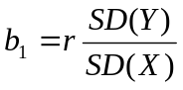
    - In Excel, use “ =SLOPE( [list of Y’s] , [list of X’s] ) ” to get b₁

  - The y-intercept (b₀) is an estimate for what Y would be when X = 0
    - By hand, 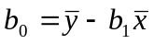
    - In Excel, use “ =INTERCEPT( [list of Y’s] , [list of X’s] ) ” to get b₀

  - The standard error of Y given X (SE_{Y|X}) is a basic measure of the average spread around the regression line
    - For any individual point, the residual is e_{i} = y_{i} – [predicted y_{i}]
    - “Average spread” is not meaningful if the data are heteroscedastic
    - SE_{Y|X} =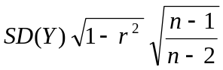 = 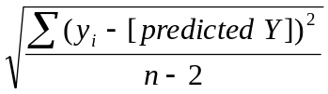~ SD(e)
    - In Excel, use “ =STEYX( [list of Y’s] , [list of X’s] ) ” to get SE_{Y|X}

- Some additional warnings about using regression for description:
  - Regressions based on averages may not apply to individuals
  - Association is not necessarily causation – coefficients do not tell you WHY

Inference for Parameters in Simple Regression

- Key assumptions

  - Y = β₀ + β₁X + ε, β's are fixed (but unknown), ε is random
  - E(ε) = 0 for all X [i.e., E(Y | X) = β₀ + β₁ X: “linear”]
  - SD(ε) = σ for some constant σ, regardless of X [“homoscedastic”]
  - ε’s are independent of each other
  - ε’s are normally distributed
    - Assumption of normality is important when predicting individual values of Y at X; assumption of normality is not as important when doing inference for regression parameters, if sample size is large

- Formulas

  - To “predict” an individual value of Y at X = x*,
SE_{indiv} =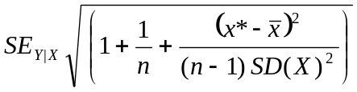 and distribution is T_{n–2}
    - SE_{indiv} is approximately equal to (slightly larger than) SE_{Y|X}
    - For predictions, it is critical that the ε’s have a normal distribution

  - To construct conf. intervals for the expected (average) value of Y at X = x*, SE(b₀+b₁x*) = 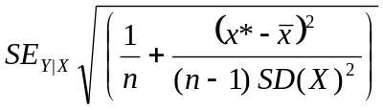 and distribution is T_{n–2}
    - SE(b0+b1x*) _{indiv} is approximately equal to (slightly larger than) SE_{Y|X}
    - If the sample size is large, it is not critical that the ε’s have a normal distribution (because of the Central Limit Theorem)

  - For the y-intercept of a simple regression line, E(b₀) = β₀,
SE(b₀) = 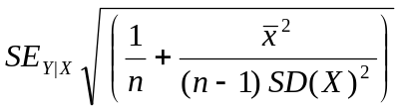, distribution is T_{n–2}

  - For the slope of a simple regression line, E(b₁) = β₁,
SE(b₁) = 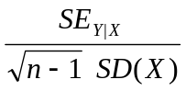, distribution is T_{n–2}

- Warning: not all relationships are linear, and even linear trends do not continue indefinitely

